ACT-IAC Blockchain Playbook

Assessment Section

**Section Leads:** Aleks Zelenovic (Sapient), Star Vanamali (Sapient) & Sandy Barsky (GSA)

**Date:** March 2, 2018

**Suggested Length:** 4-5 pages; Current Length: 11 (with graphics)

**Audience:** Business Owners and Government Execs

**Overall Purpose and Goals:** As blockchain is an emerging technology, both Gov and Industry are still discovering what are best practices, approaches and how to evaluate offerings, technologies and approaches. This section provides guidance on assessing Blockchain offerings, technologies, … and when to apply them.

Table of Contents

Introduction (Suggested: .5 pages) 2

Setting the Stage 2

“Do I need a blockchain?” 2

Practical Advice and Best Practices Around Blockchain Assessment (Suggested 1 page) 3

Start Small - Implement a Minimal Viable Product(MVP)/Prototype 3

Build Blockchain Architectural Blueprint for Future Phases 3

Emphasize ROI and benefits to the entire network 4

Impact of Modernize Government Technology (MGT) Act 4

Incorporate Regulations/Mandates 5

Determine Throughput and Latency Requirements of Business Processes 5

Assess Current State of Customer Experience 5

Outcomes (Suggested: 0.5 page) 5

Clearly define few deliverables/outcomes of the assessment 5

Link to Readiness 6

# Introduction (Suggested: .5 pages)

This section helps decision makers create the most value through their blockchain initiative. It includes tools to ensure the best solution is planned for addressing a specific use case and advancing toward mission goals, even if that solution is not blockchain/DLT.

## Setting the Stage

Engage with stakeholders to refine the use case the blockchain initiative will address. Identify and document the context of the use case. This includes the business challenge; business process issues, gaps, and/or frictions that contribute to that challenge; and stakeholder needs. Detail the stakeholders’ functional requirements. Also determine their perceived risks related to implementing a solution along with their expected outcomes and the associated metrics.

With the advent of Cloud, every business decision maker was faced with making a choice. The problem however was not just the definition of Cloud – but: “*How does Cloud improve my business*?”

Digitalizationisposing the same challenges again.

Todays business world is not linear. It is dynamic. It is asymmetric. It is 3-Dimensional.

Unfortunately, most businesses operate in a very hierarchal manner. Models have hardly changed – adapted or evolved – for the last two decades. Technology has advanced exponentially. People and culture struggle to keep pace with such advances. More importantly, the executive is overwhelmed.

As always, succesfful organizations and leaders are those who are able to master this reality.

A model now emerging from the digital landscape are Decentralized Organizations. These are business operations that leverage autonomous, secure, business logic, with Blockchain technology. Routine – even complex routine – activities are done automatically, without human intervention.

The Value: This allows organizations to focus on their core competency.

In addition, Operational Expenses (OPEX) are optimized.

From the executive lens, Blockchain is the chassis. The true business transformation is the model itself: Decentralized Organizations. Challenges are not absent. This is a tectonic shift for the business. Executives need to prepare their leaders, associates, and, culture for such adoption.

The below diagrams differentiates between Centralized and De-Centralized:

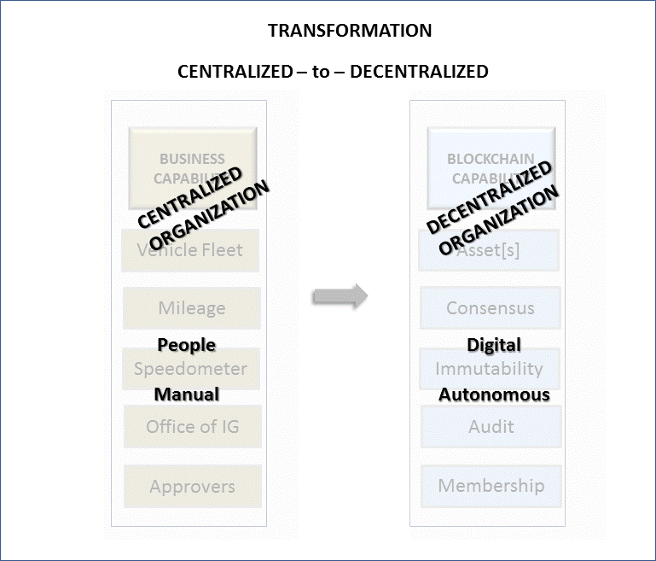

# “Do I need a blockchain?”

[*CONTRIBUTOR: Jim, Jeff and team*]

When considering a blockchain solution, consider both the benefits and the limitations associated with a blockchain solution; such as will a blockchain solution remove some of the existing business frictions associated with the “as-is” business process? Do characteristics such as trust, immutability and finality provide significant value for the use case being evaluated? Will those benefits ultimately result in a reduction in cost or reduction in risk or will they achieve process efficiencies? Are there additional benefits that can be realized by growing the business network associated with the solution? This should be done while also considering qualifying factors such as the rules and regulations which need to be adhered to and how the blockchain solution may integrate with existing systems. Here are some key questions to consider when evaluating a blockchain solution. Note: A discussion regarding public versus permissioned blockchains is provided in the selection section of the playbook.

Can you map your business capabilities to Blockchain capabilities? Below is an example of a GSA vehicle fleet model. The stakeholders need to track mileage of vehicle usage across various agencies, users, and states.

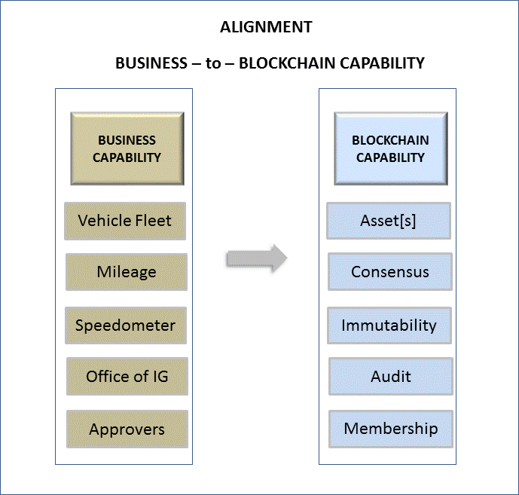

The below qualifying questions are bucketed into three logical groupings: Blockchain (technical), business, and, GRC (Governance, Risk, Compliance). As with requirement gathering, these will serve as inputs and outputs across this methodology.

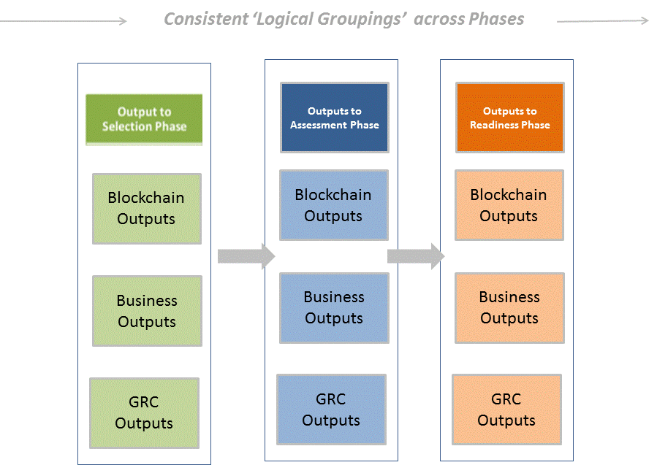

Review and answer each question below.  Add or subtract the points associated with each question to determine your total score.  A point total of 1-15 indicates…. A point total of 16-30 indicates…. . A point total of 31-50 indicates that you may get a substantial ROI from a blockchain approach.  Note that this is a notional table and the level of importance associated with each question may be tied to the use case being assessed.  Assign Points based on Attribute Importance Rank (with suggested weighting).  You may adjust weight of questions for your use case. (5 - Critical, 3 - High, 2 – Moderate, 1- Slightly)

1. Are you executives and senior leadership prepared to transform the respective business capabilities into a Decentralized Organization (DO)?
2. If you are able to repurpose business logic to a DO – have you identified how your Core Competencies will benefit?
3. **Will the use case involve a business network which spans multiple organizations/agencies?**While a single organization may be used for an initial proof of concept or pilot, the varying degrees of trust amongst multiple organizations/agencies lead to a stronger long-term case for blockchain.
   * 1
   * 2
   * 3
   * 4
   * 5
4. **Is there a current lack of trust amongst the business network participants and/or sources of data?**  Sources may include IoT devices, legacy systems, service providers, and users from multiple agencies.   Note: The Blockchain may not prevent poor data quality.
   * **1**
   * **2**
   * **3**
   * **4**
   * **5**
5. Is there a need to create a Custodian [Owner] of Membership for the Actors and Organizations within your process?
6. **Does the use case require or can it benefit from strict transaction immutability?** Ledger transaction entries are append only.    Transaction records cannot be altered (even by the admin).
   * **1**
   * **2**
   * **3**
   * **4**
   * **5**
7. **Does the use case require or can it benefit from using distributed ledgers and a decentralized authority approach?**
   * 1
   * 2
   * 3
   * 4
   * 5
8. **Are there existing inter-organization business process inefficiencies?**(e.g. an  excessive amount  of  time  being spent on reconciliation?)
   * 1
   * 2
   * 3
   * 4
   * 5
9. **Are you looking for a vehicle to securely share reference data amongst members of the business network?**
   * 1
   * 2
   * 3
   * 4
   * 5
10. **Does provenance of a digitized asset-tracking the lifetime history of an asset as it is controlled/owned by different members of the business network apply?** (e.g. moving from factory to distribution center to final destination across the life cycle)?
    * **1**
    * **2**
    * **3**
    * **4**
    * **5**
11. **Is this a use case that can be more efficiently solved with other technologies (e.g. distributed database)?** Do those technologies provide the same benefits that a blockchain solution will provide for this use case and would this solution be applicable for all parties?
    * **-1**
    * **-2**
    * **-3**
    * **-4**
    * **-5**
12. **For this use case, is there an existing system that could serve as a trusted source of the truth for all parties?**   Would that system be accessible by all parties?
    * **-**1
    * **-**2
    * **-**3
    * **-**4
    * **-**5
13. **Does the use case have high performance requirements? (TPS  >  3K/sec)?** Note: high performance/near real time requirements are typically not yet met by blockchain solutions, but platforms and performance numbers will continue to evolve.
    * **-**1
    * **-**2
    * **-**3
    * **-**4
    * **-**5

Results:

Score falls between 1-15: Based on your answers…

Score falls between 16-30: Based on your answers….

Score falls between 31-50: Based on your answers…

Possible graphic results:

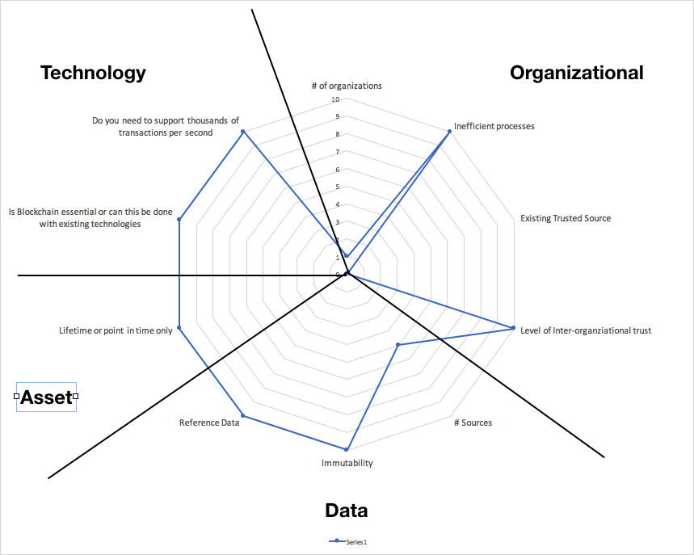

# Practical Advice and Best Practices Around Blockchain Assessment (Suggested 1 page)

*[CONTRIBUTOR: Sandy, Mark, Jeff, Sudha]*

With blockchain near the top of the hype cycle in 2017 [insert link to gartner hype cycle], it is important to separate reality from the hype when it comes to which uses cases can actually benefit from a blockchain solution. Consider the following advice and best practices when evaluating blockchain for any use case.

## Start Small - Implement a Minimal Viable Product(MVP)/Prototype

Start small. Before addressing how to introduce this new technology into your ecosystem, define the scope of an MVP/proof-of-concept that demonstrates blockchain as a viable solution for your use case. Do this while still considering the future state and stakeholder incentives. The MVP should help prove solution expected outcomes (e.g. decreased reconciliation costs) associated with the MVP hypothesis.

## Build Blockchain Architectural Blueprint for Future Phases

Develop a vision and a plan for the additional requirements and challenges that will need to be addressed if your solution moves into a pilot phase and subsequent operational phases. This should encompass modernization and integration with legacy systems. The project will also include major change management components both from an operational and cultural perspective.

The organization should examine the desired technologies and subsequent capabilities that can be enabled by the future-state blockchain solution. For example, an operational blockchain logging security events may be combined with artificial intelligence as part of a new capability that is a predictive cybersecurity force multiplier. Or a blockchain for supply chain may become the entry point to a property management workflow solution.

Building a working blueprint of the technical architecture will provide a powerful tool for defining the scope and phases of the comprehensive blockchain implementation. Strategic scaling will enable you to optimally address pain points and align stakeholders while tackling one priority area at a time to ultimately accomplish transformational objectives and advance mission goals.

## Emphasize ROI and benefits to the entire network

Start small and then scale the blockchain solution. While making an assessment, emphasize ROI. Examine the solution's common costs, benefits and efficiencies for both the network as a whole and for individual members. Include design thinking based on personas and a prioritization matrix around value vs. complexity. An MVP should prove the viability of a blockchain solution, with ROI measured by gains in savings and in efficiencies, reduction of risk and the meeting of mission goals. ROI considerations should include: [Contributor: Sandy]

* Examining gains in efficiency and cost savings. An implementation should be done in small increments, keeping to a true agile methodology. This is not a lift and replace, but a gradual shift to a strategically assured positive ROI.
* How does the trust provided by a blockchain solution when exchanging data or assets impact ROI? How much effort and cost are currently spent on reconciliation?
* **Cloud first and shared services -** Blockchain relies on distributed computing concepts where nodes may reside in the cloud. Blockchain smart contracts can enable vendor provided shared services to demonstrate adherence to current regulations and policies while providing an immutable audit trail.
* Reducing risk - Understand the ROI that blockchain can provide by reducing risk. The decentralized, tamper-resistant attributes of a blockchain solution can help reduce risk associated with tampering and DoS attacks.

## Impact of Modernize Government Technology (MGT) Act

The MGT Act encourages agencies to take an enhanced strategic, incremental approach to IT with goals to drive gains of efficiency, cost savings, and lowered risk. Blockchain technology may be used to enhance an existing IT solution invest without the need to replace existing systems. Instead it can enrich existing solutions with new capabilities and functionality that can be better provided by blockchain technology.  Government cannot modernize using existing legacy technology it is through the adoption of new technology, such as blockchain, that modernization may be achieved. Strategically, if an agency has targeted an IT process to modernize, but does not have the budget to do so, it could choose a smaller project or projects that will realize savings in year one, and apply those savings (which can be banked for three years) to the larger more critical project in year two. This is a different way of modernizing around multiagency business networks and processes.  A strategic blockchain solution is extensible, able to grow over time, adding new members and processes to the business network.  It also facilitates data sharing, the reduction of existing frictions and inefficiencies.  This approach is consistent with the MGT Act narrative; therefore, the assessment that an agency must make through a standard analysis of functions and gaps is to determine if the use of a blockchain will enhance an existing solution through gains of efficiency, cost savings, and lowered risk.

## Incorporate Regulations/Mandates

When assessing blockchain or any blockchain technology, be sure to evaluate it within the context your particular use case. For example, an identity use case would require a technology that adheres to particular regulations, such as the technical requirements in NIST 800-63, Digital Identity Guidelines. Be sure to evaluate the entire technology solution—including smart contracts, oracles, side chains, microservices, any associated cryptocurrencies, etc.—with regard to industry standards, technical standards, regulations, acts, and common law.

## Determine Throughput and Latency Requirements of Business Processes

Understanding data requirements and the speed by which data transactions must occur within the blockchain ecosystem are key inputs in determining your optimal architecture, accelerators, etc. When assessing blockchain as a solution consider the number of transactions per second required, the size of the data/assets being transferred, should the data be stored 'on chain'. Where will the nodes be located? Is network bandwidth constricted? Large blockchain ecosystems with many systems and players such as public permission-less chains would be best served by minimizing data-load, whereas smaller private/consortium chains may handle a larger number of transactions per second and can theoretically handle the exchange of larger “blocks” without interruption to business processes.

## Assess Current State of Customer Experience

As with most transformative efforts, the blockchain initiative should also be used as an opportunity to enhance user experience. When assessing your use case, different users with different roles may interact with the proposed solution. Assess how blockchain could improve that user experience by automating tasks and improving visability. Robust usability testing will be key to successful user adoption as the blockchain solution is scaled outward. Users have little tolerance for solutions/systems that lack usability in the form of user-friendliness, intuitiveness, and/or accessibility. As a nascent technology, ensuring usability of the blockchain solution is doubly important in order for scaling of the solution to build and maintain momentum of adoption.

*<A callout box will be included in this section that provides links to resources where readers can explore/reference existing government use cases (e.g.* [*GSA Emerging Citizen technology Atlas*](https://emerging.digital.gov/blockchain-federal/)*. Are there any additional resources that the group recommends including?>*

# Outcomes (Suggested: 0.5 page)

[Contributors: Jeff Tennenbaum]

## Clearly define few deliverables/outcomes of the assessment

After the assessment is completed, one or more deliverables/outcomes should be produced:

* One or more use cases identified as candidates for a blockchain solution. Each use case should be evaluated against assessment criteria to determine if a blockchain can be used to realize gains such as cost saving, efficiency, or reduced risk. Which of these use cases would be sensible to implement as a minimum viable product?
* Documentation on the key stakeholders, network participants and their roles for your candidate use case. How a blockchain solution will impact your stakeholders? What are the incentives for these stakeholders to participate in the solution?
* For each candidate use case, identify what business frictions you are looking to address by implementing the solution. Do blockchain attributes help to address those frictions? This list should correlate with the list of anticipated benefits provided by the solution. Both the frictions and benefits may differ for each stakeholder.
* Identify and list any barriers regarding adoption and implementation of the solution, these may include existing rules and regulations, data ownership, data location, process ownership, and resistance from individual stakeholders.
* A list of performance and other non-functional requirements such as security and scalability. They may serve as barriers to the implementation.
* Documentation of the existing systems and data sources which may interact with the proposed solution. Examine the integration challenges when interacting with those systems. Could implementation of the solution lead to retirement of a legacy system?
* A model of what the operational end state would be after implementing a blockchain solution. This should be done initially for the MVP/PoC and again for a solution once the scope has been expanded. What should the outcomes be after implementing this solution?
* With the operational end state identified, a list of the anticipated benefits.
* Documentation regarding alternative solutions including a list that identifies the pros and cons associated with alternative solutions.
* Documentation regarding existing assets and/or licenses which may be required for the use case. Are there entitlements associated with those assets?

## Link to Readiness

The artifacts generated during the assessment phase, such as the documented use case, the stakeholder analysis, the vision of the operational end state, and other deliverables, directly support and should be leveraged during the readiness phase.

